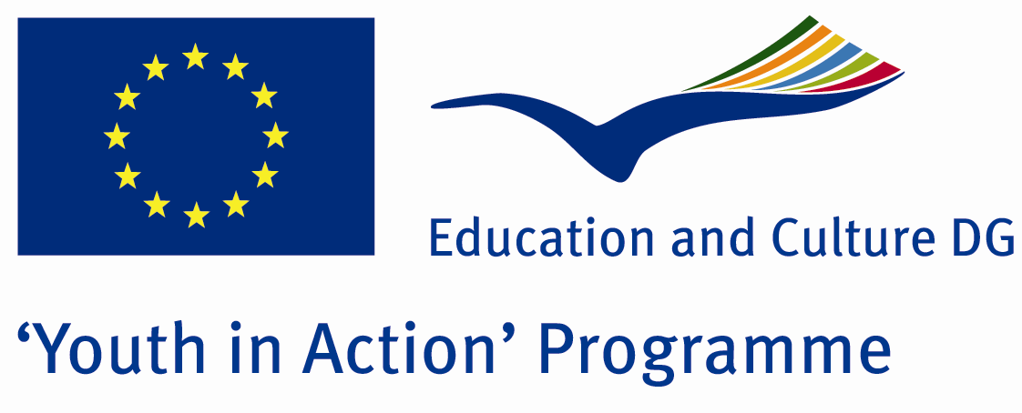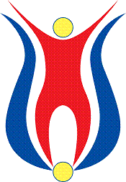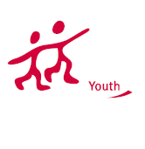

Action 1.1
Project Summary; Integrated the art with the nature our project helps you to explore secrets of basic paper and realise the importance of the nature. In some workshops origami has been taught, you can have the oppurtunity to interact in protecting the natural beatuies so that we can announce the people all around the world can realise that we are naturalists and world as a whole has great importance for all of us.
Project Title; From Nature to Art
Date and Venue ; 22-29 2013 March Turkey
Place: Bartın.

Target Group ; Municipalities, City Councils and Non-Governmental organizations,
youth groups,culture and art groups,e.t.c

Participants ; 5 people from each country (over 18 -25 ). Totally 7 countries.

Conditions ; Accommodation, board and programme costs will be financed through European Commission Youth in Action Programme . Travel costs will be reimbursed in 70% (APEX Tarrifs). Organizations from all 27 EU member countries plus Liechtenstein , Norway and Iceland are eligible to take part.

Working language: English

Organisator group: Paper artistes

How to apply: If you are interested, please send your Part III forms to
by e-mail please (in word file). Scan Part3 format is enough for application.(Fulfilled Part III which you can find in the attachment, of course signed and stamped) ..

Contact e-mail: groupsymrnes@gmail.com
Group e-mail: grouppaperr@gmail.com

Deadline to apply:20.09.2012

